Public Workshop Summary

Meeting Information
Date | February 28, 2022, from 5 PM to 7 PM, March 12, 2022, 10Am to 12PM, April 23, 2022 from 10 AM to 4 PM
Location | Warren Co Armory, Drewry Fire Department, and Springfest (109 South Main Street)

Overview
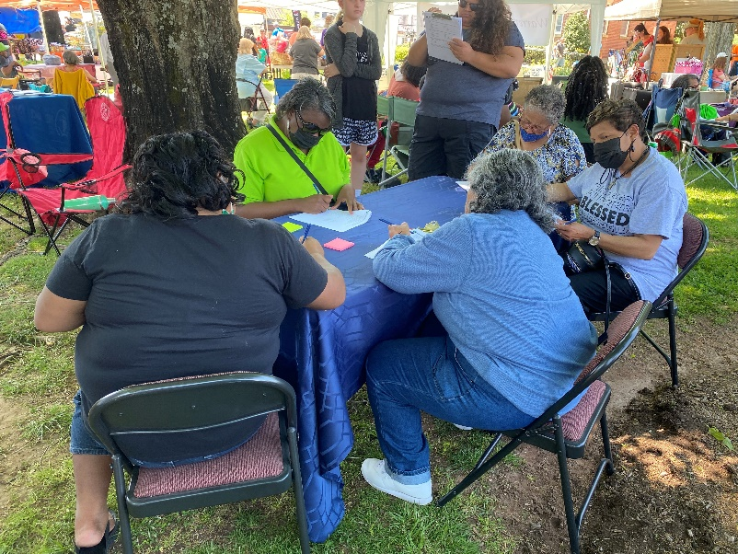
The public workshop for the Warren County Comp Plan allowed attendees to engage with the Plan via informational materials, feedback activities, and small group discussions. About 34 people attended the public workshop on February 28th; additionally, there was a public meeting on the 12th of March 2022. Additionally, County staff set up a table with the same activity boards and informational boards at Springfest on Main Street in downtown Warrenton on April 23. There were three feedback activities: Parks and Open Space Preferences, Development Preferences, and Vision and Goals. All three activities encouraged participants to indicate whether they support or do not support each action item. The results from all three workshops are included below:

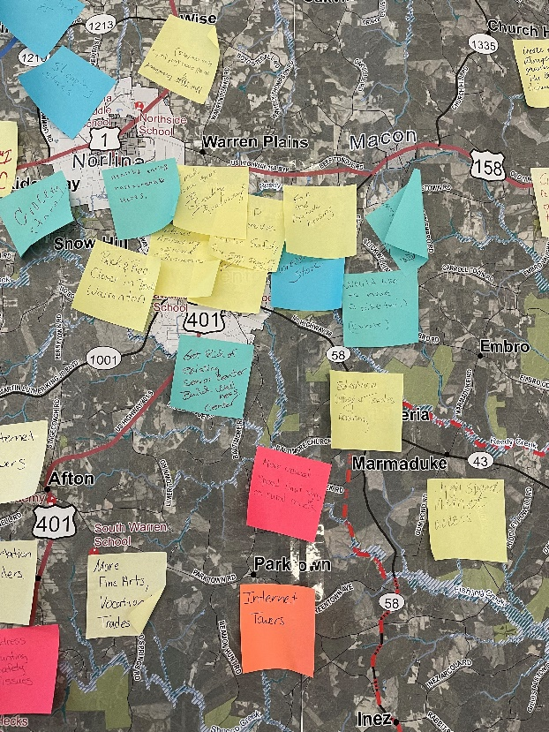
Keep/Toss/Create Map Comments
A Keep, Toss, Create activity allowed participants to highlight areas in Warren County they wanted to keep or needed improvements and opportunity areas. Comments are summarized by portions of the county and are as follows:

South
- High speed internet access
- Cellular towers
- Transportation for elders
- Grocery stores
- New senior center
- Parks and rec in Warrenton
- Improve public safety
- Beautify roadways
- Expansion of US 158 North of US 1 in the Ridgeway community
- More retail opportunities

North
- Public access at Lake Gaston
- Stronger presence of the Brick Spring fishing pier
- Create a recreational trail on railroad tracks along 158
- Internet access
- Bike trails
- Fair and equitable housing
- Grocery stores
- Educational opportunities both collegiate and trades

East
- Four-wheeler trails
- Hospital facilities
- Internet access
- Increase number of speed limit signs on rural roads

West
- Internet access
- Fine arts & vocational trades academy
- Address hunting safety issues
- Affordable housing
- Increase small businesses

Development Preference
The activity asked them whether they support or do not support the development type as well as if they would prefer to see the specific development type in agricultural areas or activity areas. This feedback will aid in development of the Future Land Use Map, character areas, and land use recommendations for the plan. Overall, there was strong support for preserving agriculture and medium-density residential and small-scale commercial located in activity areas near major roads, crossroads, or near towns. Additionally, there was support for employment related uses and mixed results on the location of medium-to-large scale commercial and low-density residential uses.

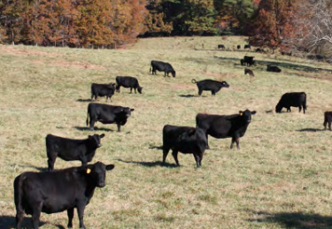
Rural/ Agricultural
Rural homesteads and agricultural lands consist of homes on very large properties including working farms and some agricultural related commercial buildings. This type of land use was generally supported. A few participants supported this kind of development located in agricultural areas or less developed areas.

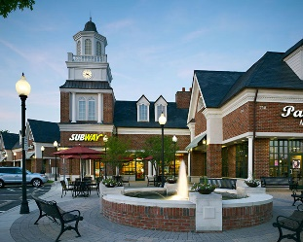
Commercial
Support was in favor of both small scale and medium to large scale commercial development. Many participants would like to see commercial development in activity areas.

Small Scale
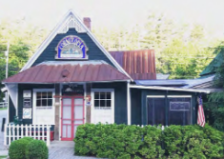
Small scale commercial consists of smaller scale commercial buildings and business including gas stations, restaurants, and shops. Input was in support of small-scale commercial in general. A significant number of participants would like to see small scale commercial in activity areas such as near major roads, crossroads or near towns.

Medium to Large Scale
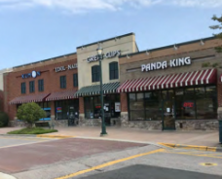
Medium to large scale commercial buildings include grocery stores, shopping centers, and storage facilities. Approximately, 64% of participants supported this type of development, while 23% did not support medium to large scale development. Out of the participants that supported medium to large scale development a few participants supported this type of development in activity areas (i.e., near major roads, crossroads, or near towns).

Employment Related Uses
Employment uses such as manufacturing, offices, and distribution were supported by participants. Overall participants supported this type of development. Some participants preferred this type of development to be located in less developed areas while others preferred this type of development near major roads, crossroads, or near towns.

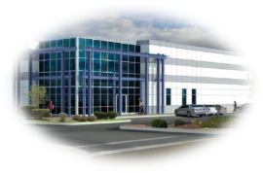
Residential

Low-Density Residential
Low-density residential includes single-family homes on lots greater than a ½ acre. All participants supported this type of residential development. Some participants preferred low-density residential development to be located in activity areas (i.e., near major roads, crossroads, or near towns), while others did not indicate their location preference.

Medium-Density Residential
Most participants supported medium-density residential, however some participants did not support medium-density residential. There was a higher preference for medium-density residential development to be located in activity areas (i.e., near major roads, crossroads, or near towns) versus being located in agricultural areas.

Transportation/Infrastructure
Participants wanted to note traffic on Drewry Virginia Line Rd. Also include HWY 158 in text.

Parks, Recreation and Open Space
For the Parks and Recreation and Open space preferences, participants were encouraged to indicate what types of recreation facilities and open space priorities they would like to see prioritized in the plan. The top four choices on for parks and facilities priorities were greenway & trails, programming & events, lake access and playgrounds. The top four preferences for open space were outdoor recreation access, protection of water quality, protection of habitats and rare species and agricultural preservation. A few participants left comments indicating their desires for a dog park, a new centrally located senior center/wellness center, and equipped with programs and services for all ages.

Vision and Goals
These goals were identified in Warren County’s most recent comprehensive plan, which was adopted in 2002. Participants were instructed to place a dot to indicate if you support or don’t support the goal. They were also encouraged to leave comments. All participants were generally in support of the goals but many provided comments on additional priorities or specifics that should be addressed in the plan.

To promote, expand, and diversify the economic base and job opportunities.

To promote, encourage, and stimulate the conversation of existing housing and the construction of new housing.
To provide and maintain adequate county services and facilities to accommodate economic development and growth, and to protect the public health and general welfare.

To encourage development at a rate and in a pattern which can be efficiently served by existing and planned services and facilities.

To develop a transportation system that will address economic development and local travel concerns.

Vision and Priority Goal Comments

Additional Feedback from February 28, 2022

Comment Cards
Meditation parks for yoga and meditation courses would also be an excellent addition to unite and increase positive energy here in Warren County.
Students, children, parents, elders and more would love to tour and explore natural resources in Warren County such as lake Gaston possibly offering swimming lessons, learning about different plants, habitats, species, environments, etc. Students need weekly field trip and tour dates to learn and study our natural resources- hands on.

Comments Sheet

Combined Results from Public Workshop and Springfest

Land Use Preference

Residential Preference

Parks, Recreation, and Open Space Preference

